**Model Development Phase Template**

|  |  |
| --- | --- |
| Date | 17 July 2024 |
| Team ID | xxxxxx |
| Project Title | Predicting The Energy Output Of Wind Turbine Based On Weather Condition |
| Maximum Marks | 4 Marks |

**Initial Model Training Code, Model Validation and Evaluation Report**

The initial model training code will be showcased in the future through a screenshot. The model validation and evaluation report will include Mean Absolute Error, R2 Score for multiple models, presented through respective screenshots.

**Initial Model Training Code:**

1. Random Forest Regressor

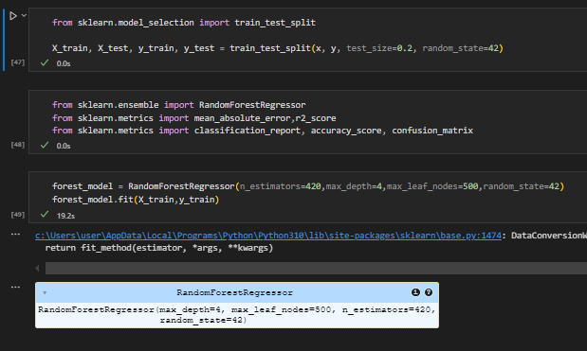

1. Linear Regression

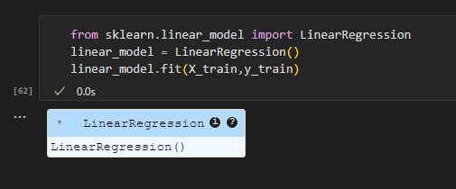

**Model Validation and Evaluation Report:**

|  |  |  |
| --- | --- | --- |
| **Model** | **Mean Absolute Error** | **R2 Score** |
| Random  Forest  Regressor |  |  |
| Linear  Regression |  |  |